For Immediate Release Contact: Name
May X, 201X Phone Number
Email Address

MAKES IT PURPLE TO SUPPORT FALLEN FIRST RESPONDERS
Writing Contest for Children

(Insert City/State/date) – Over 300 first responders: police, fire and EMS have died in the line of duty in Texas since 2000. This year alone, 6 public servants have died in the line of duty. It’s a scary statistic and it’s one of the reasons why the Texas Line of Duty Death Task Force has launched the Make It Purple: Fallen First Responder Awareness Month and the Dress in Purple Day. This event will help incite awareness of what our local first responders go through on a day to day basis, as well as for those that have died in the line of duty and their families that they have left behind.

“We want to make a difference in the lives of our local first responders, their families, and their communities. Our Make It Purple: Dress in Purple Day event encourages citizens to go out and encourage local first responders, talk to loved ones about how they can support them, and to remember those that lost their lives in the line of duty. By creating more awareness around this issue, we will help provide more support and care to those that continue to serve and to those families that have been left behind,” said Wendy Norris, President of the Texas LODD Task Force. “It’s important that we do our part by helping these families.”
Along with the Texas LODD Task Force, Governor Greg Abbott has proclaimed May to be Fallen First Responder Awareness Month. He states, 'Texans owe a debt of gratitude to all of our first responders who dedicate themselves to serving the public and put their lives on the line every day to ensure our safety. These men and women are examples of courage and honor, and it is our duty to honor their sacrifice and remember the legacy they leave behind.’
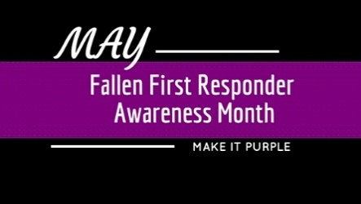
Along with the Dress in Purple Day , the Make It Purple Campaign will be holding several contests for community members to get involved. One such contest is a writing contest for children. Children will be able to choose a topic that is pre-selected on the website, and write a story or article on their chosen topic. Children will be grouped in three different age categories. One winner from each age group will receive a Make It Purple goody bag and a gift card.
Teaching our children about our local first responders, what they do and how those individuals care for their communities is paramount in showing that there are men and women out there that are true heroes.
We would like to encourage your (school, church, daycare, group) to participate by encouraging your children to participate in our writing contest. Through these initiatives and by “Making It Purple” we hope to raise public awareness and support the families of the fallen and our first responders.
For more information and to get involved, visit www.makeitpurple.org.
# # #

